

SCHOLARSHIP APPLICATION FORM 2025

**1st place - Steve Morin Scholarship - $3000**

Sponsored by: CMC Associate Members

**2nd place - Ron Osborne Scholarship - $2000**

Sponsored by: CMSA and CMC Associate Members

**3rd place - HyLife Scholarship - $1000**

Sponsored by: HyLife

|  |  |  |  |  |  |
| --- | --- | --- | --- | --- | --- |
| **PERSONAL INFORMATION** | | | | | |
| **Family name of applicant** | | **Given name(s) of applicant** | | | |
| **Current mailing address** | | | | | |
| **Street** | | | | | **Apartment number** |
| **City** | **Province** | |  |  | **Postal Code** |
| **Permanent mailing address (if different from above)** | | | | | |
| **Street** | | | | | **Apartment number** |
| **City** | **Province** | |  | **Country** | **Postal Code** |
| **Telephone number** | | | **Cellphone number** | | |
| **Email address** | | | | | |
| **University and Department attending** | | | | | |
| **Program (Masters or Ph. D)** | | | | | |
| **Current Year in Program** | | | | **Expected Date of Graduation** | |
| **Name of Supervisor** | | | | | |
| **Supervisor’s email address** | | | | | |

|  |
| --- |
| **List of Graduate level courses you have taken/are currently taking** |
| **Do you hold any other scholarships? Please list donor agency and amount for each.** |
| **Describe your future plans following graduation** |

|  |
| --- |
| **Title of Research Project** |
| **Summary of Objectives of Research Project (Maximum 1/2 page). Please list succinctly.** |
| **Describe Research Project (Maximum 2 pages – attach as separate document)**  - **Please include background, objectives, experimental design, current status. Must include at least three key references important to the development of your project.** |
| **Is the project being done in collaboration with an industry(s) supporter? Is the project supported by a grant program?** |

|  |
| --- |
| **Describe Scientific Merit of Project**  **(e.g. - contribution of the research to basic scientific knowledge; will the project lead to the development of significant new knowledge and/or useful technology)** |
| **Describe Innovation of Project**  **(Is it innovative and if so, why; are you aware of any other data/studies relevant to this research effort; has the research been duplicated elsewhere)** |
| **Technology transfer – Has the project work been presented at any conferences or are there any publications resulting from the research? Are there any patents submitted on the research?** |

|  |
| --- |
| **Describe Potential Impact of Project on the Meat Industry.** |
| **Describe Benefits Relating to Meat Science** |

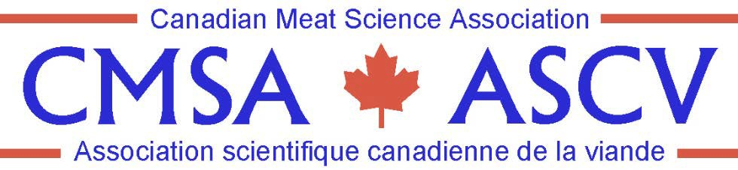

The CMSA Scholarship program has been updated! Winners will be invited to present at the CMSA Symposium on May 27, 2026.

The 1st place presentation will be awarded the Steve Morin Scholarship ($3000), 2nd place will be awarded the Ron Osborne Scholarship ($2000) and 3rd place will be awarded the HyLife Scholarship ($1000).

# Scholarship Application Checklist

1. **Application Form**
   * It is strongly recommended that your application be critically reviewed by a professor or student advisor(s) prior to submission.

# Two Letters of Reference

* + The referees must be able to provide a professional assessment of your academic, personal skills, and research potential.
  + One letter must be from one of your professors.
  + Both letters must be on the organization’s official letterhead.
  + Both letters must be emailed to [canadianmeatscience@gmail.com](mailto:canadianmeatscience@gmail.com) and must be sent directly from the referee’s email address.

# Transcripts

* + Official transcripts are required from your current college/university.
  + They must include the most recent semester completed at your current college/ university.
  + Transcripts should be scanned and emailed to [canadianmeatscience@gmail.com](mailto:canadianmeatscience@gmail.com).

# The Deadline to receive your application is August 29, 2025

* + Please include all the required documents (other than reference letters) in one email.
  + Email your application packages to [canadianmeatscience@gmail.com](mailto:jennmitchell.tfio@bellnet.ca).
  + Make sure you have registered and paid to be a student member of CMSA – [JOIN CMSA](https://cmsa-ascv.ca/?page_id=96).

# Late submissions will not be accepted.